Experiment 28
You cloned a repository earlier, and now another collaborator has made changes to it. You need to pull the latest changes from GitHub to keep your local copy up to date.
Tasks:
- Clone a repository (from previous questions).
- Ask a collaborator to make a change and push it to the GitHub
- repository.
- Use git pull origin main to pull the latest changes.
- Verify that the changes made by your collaborator appear in
- your local repository.

Step 1: Create a GitHub Repository by the Collaborator
A GitHub repository was created by the collaborator to demonstrate collaborative version control.
Repository: library-project
The repository was initialized with a README.md file.
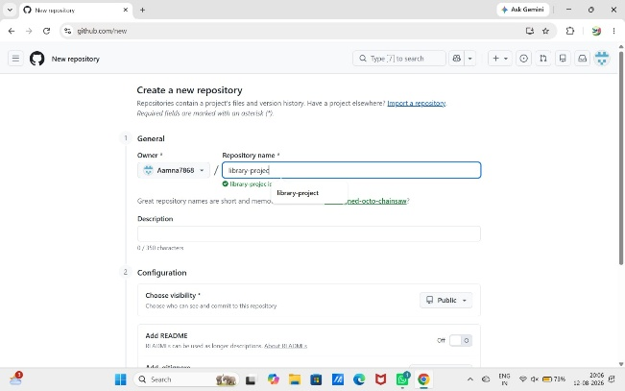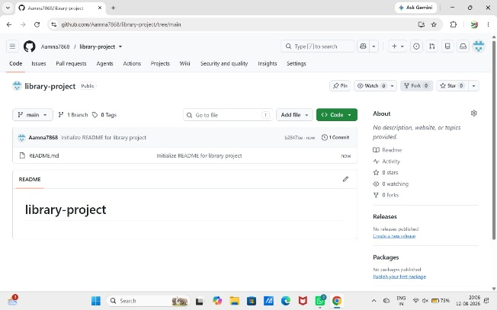
Step 2: Clone the Repository
The repository was cloned to the local computer using Git Bash.
git clone https://github.com/Aamna7868/library-project.git
The repository was successfully downloaded to the local machine.
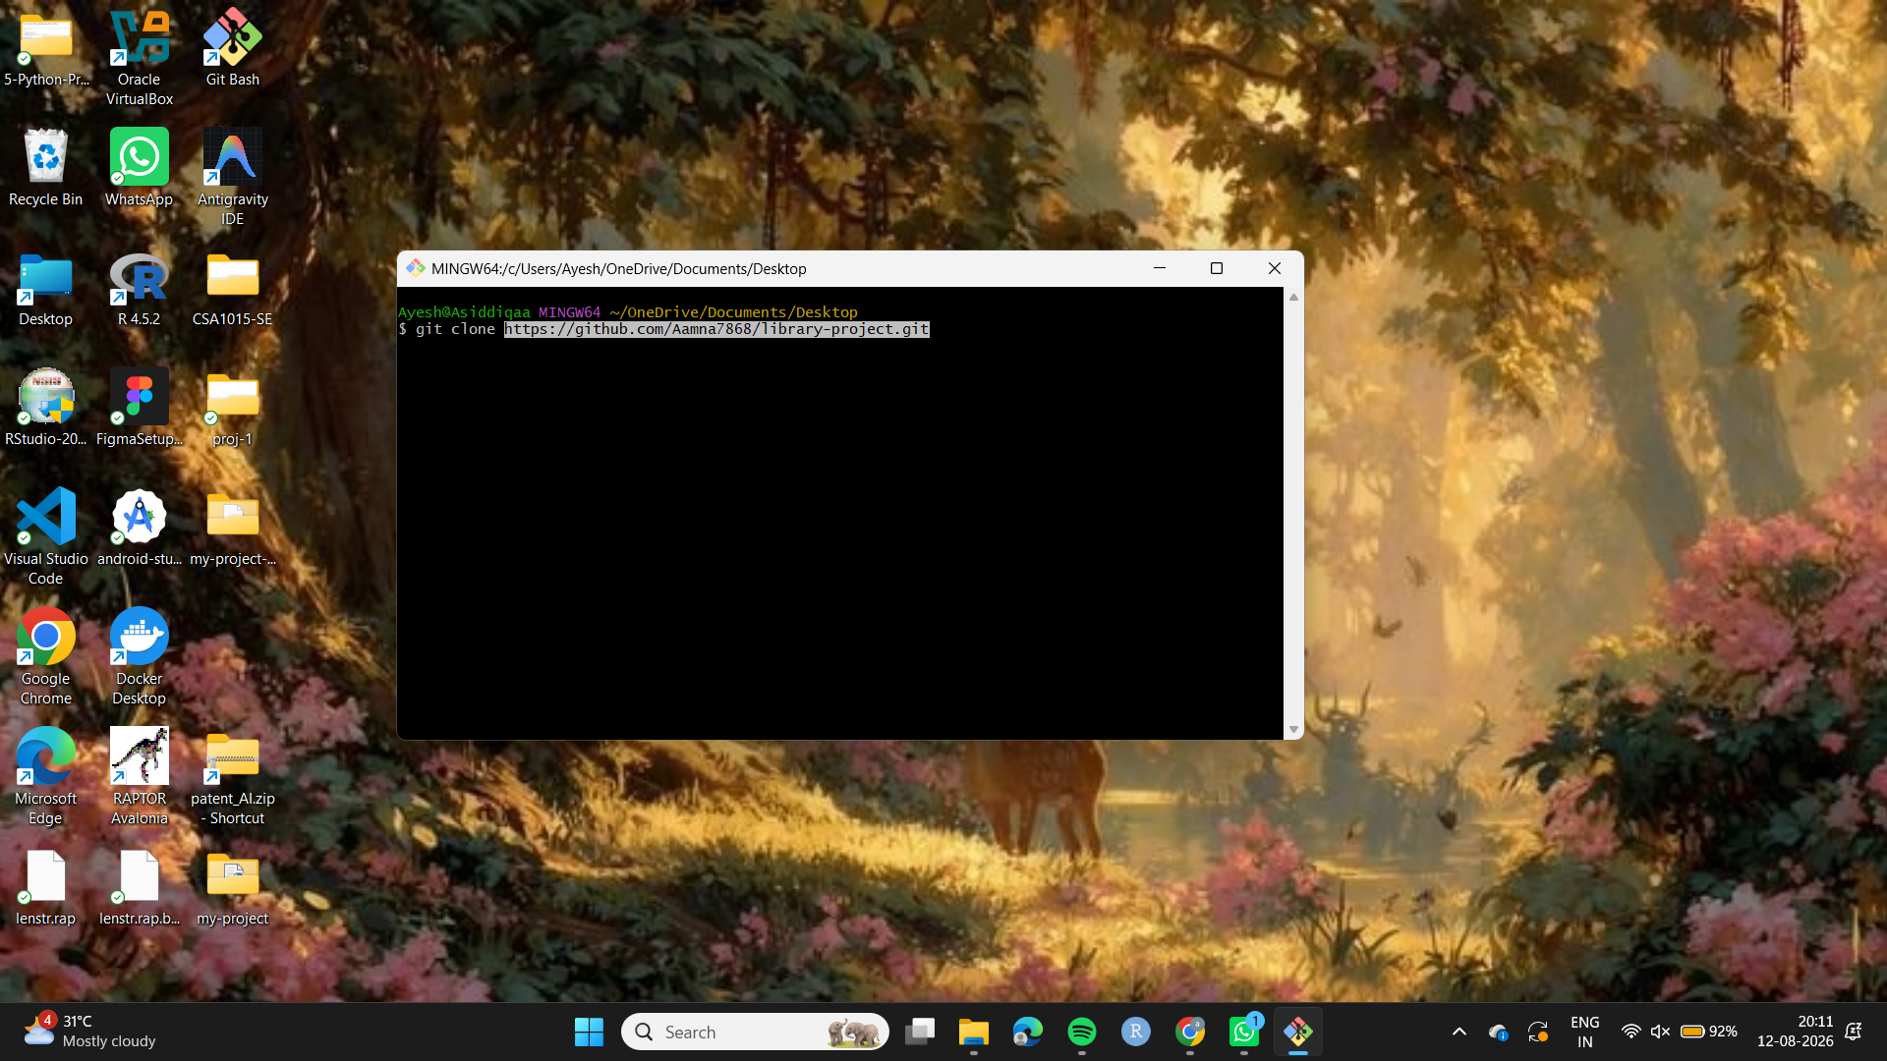

Step 3: Navigate to the Repository
cd my-project
The terminal was moved into the cloned repository directory.
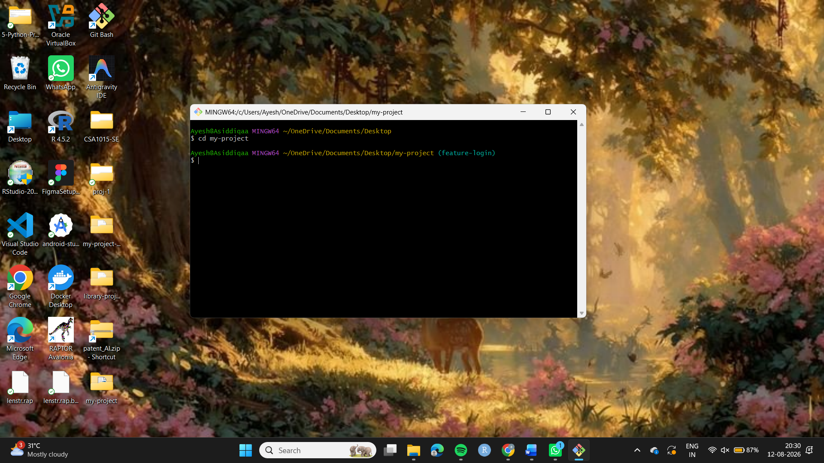
Step 4: Collaborator Makes a Change
The collaborator made a small change to the README.md file on GitHub.
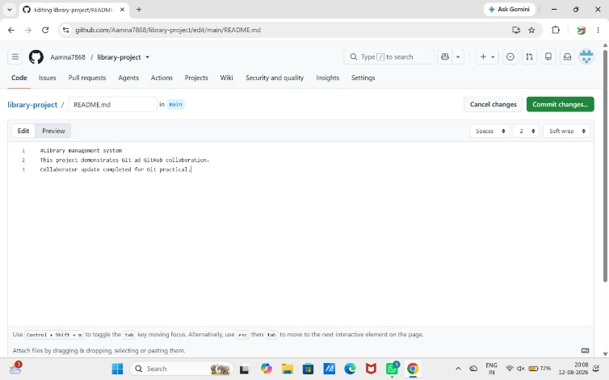
Step 5: Check the Local Repository
In Git Bash, the following command was used:
git status
This checks the current state of the local repository.
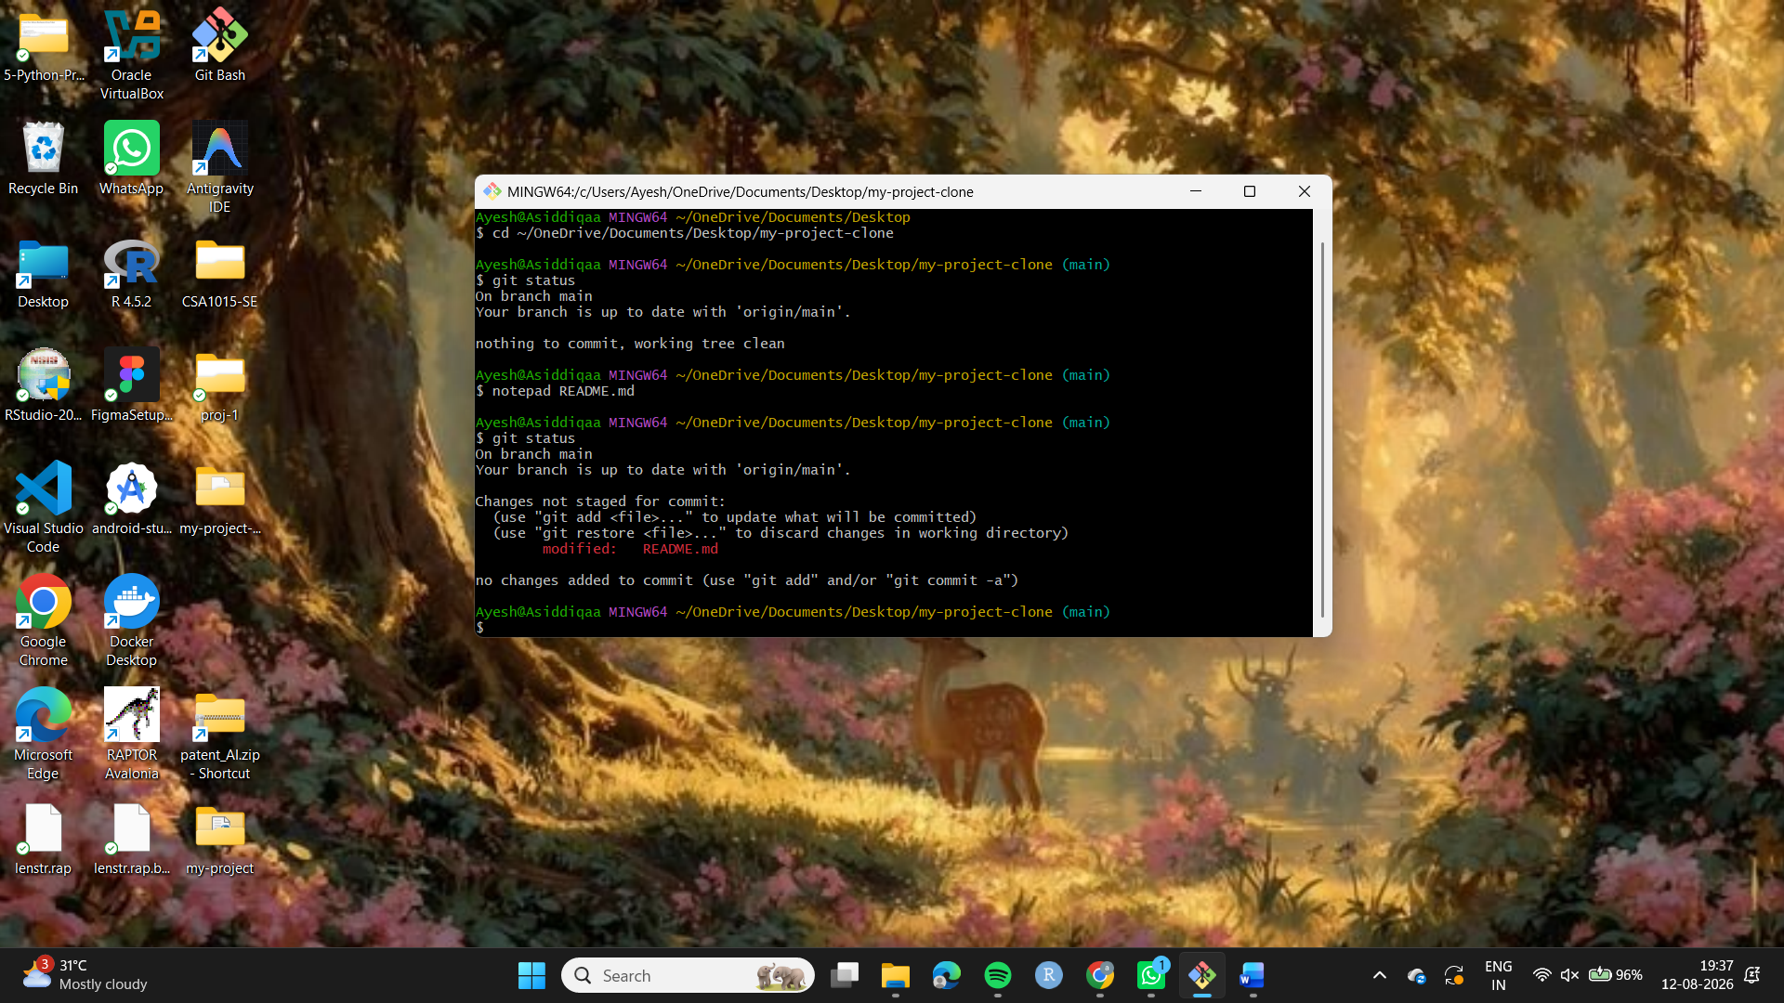
Step 6: Pull the Latest Changes
The latest changes made by the collaborator were downloaded and merged into the local repository using:
git pull origin main
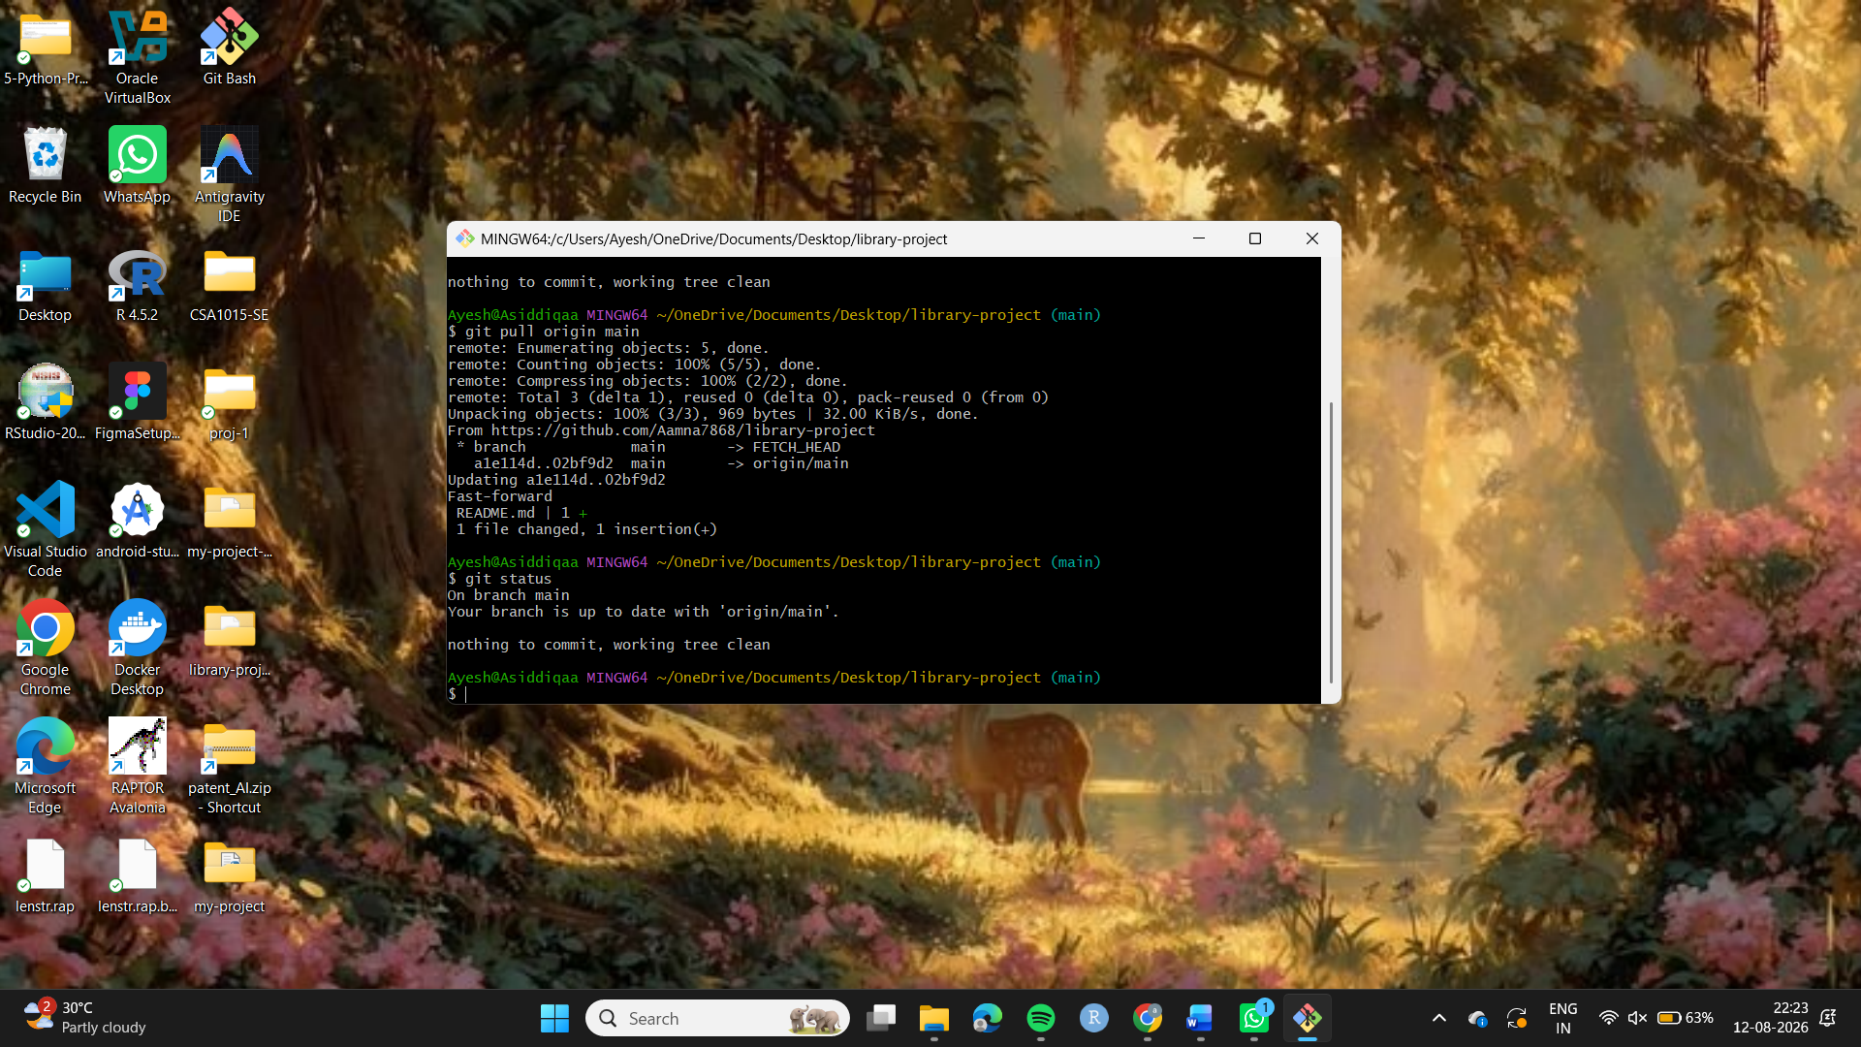
Step 7: Verify the Changes
The README.md file was opened from the local repository.
The new content added by the collaborator was visible in the local file.
This confirmed that the latest changes from GitHub were successfully pulled into the local repository.
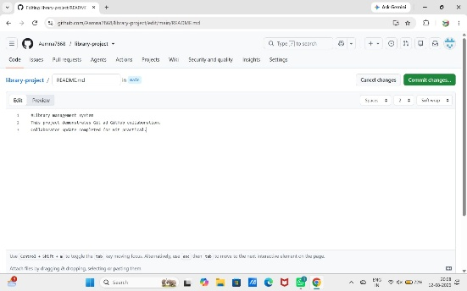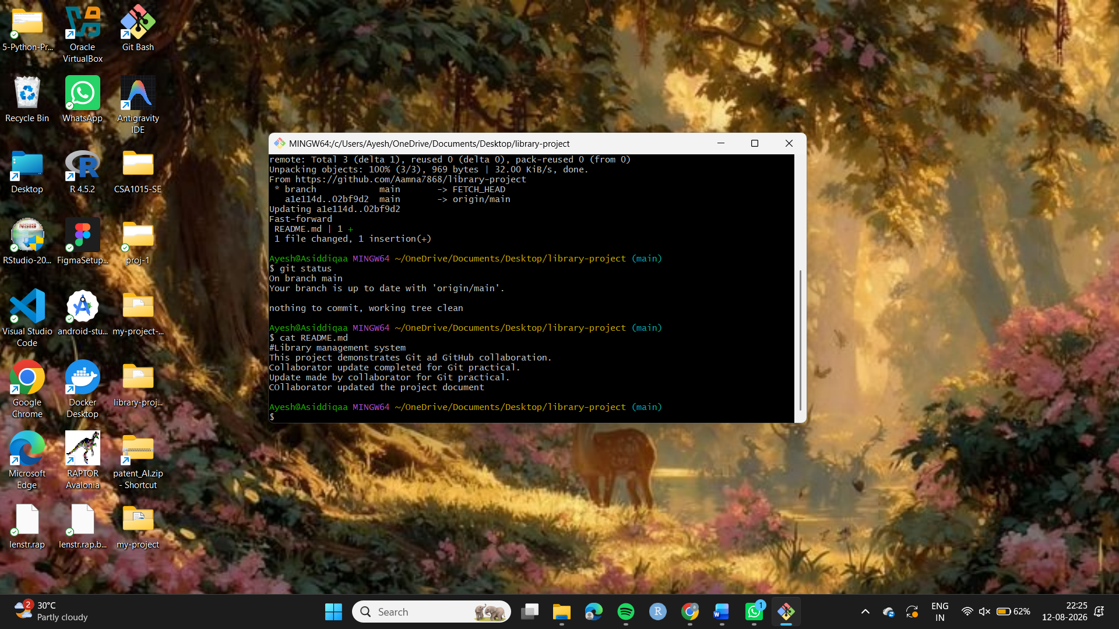
Result
The repository was successfully cloned, updated by the collaborator, and synchronized with the local machine using git pull origin main. The changes made by the collaborator were successfully verified in the local repository.

